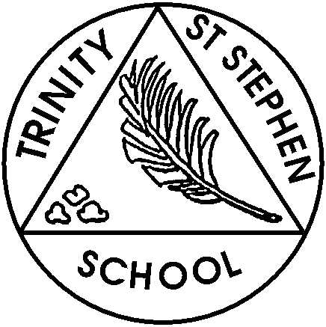

Monday 11th November

This week in Reception

This week we will be continuing our topic ‘Light and Colour’ and the focus will be based around the book ‘Brown Bear, Brown Bear, what do you see?’
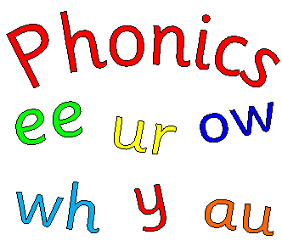
Phonic focus for this week
This week will introduce phase 3 sounds ‘z/zz’, ‘w’, ‘y’, and ‘x’. We will use Jolly Phonic actions and songs to help support the learning. We will practice reading and writing the tricky words we have covered – I, the, to, go and no.
Maths
This week we will be learning to use everyday language related to money, recognising coins and making amounts up to 10p/20p..

What can you do at home?
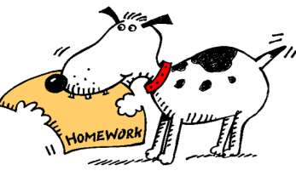
- Please help your child practise the sounds and make sure the sound book is in their book bag the following Thursday so the new sounds can be stuck in.
- Practise reading the tricky words we have covered. Mini flashcards are at the back of your child’s sound book and you can look for the tricky words in books
- Look at coins, discuss the value, can they make small amounts?
- Keep practising name writing using the school script.
- Practise putting on and taking off coats and jumpers, some children are finding it particularly difficult when sleeves are inside out. Also, practise doing up zips on coats.

Action points
- Show & Tell will be this Friday 15th November for Group 3 and the theme is ‘Autumn’. The children can bring in autumn objects collected from a walk, photos of them on finding autumn objects or they can make an autumn picture using autumn objects. It is up to you, you can be as creative as you like. The following week 22nd November will be Group 1. The topic will be 2D shapes. The children could go on a shape hunt and take photos or draw a shape picture. Be as creative as you like. The children need to be able to name the shapes and describe them, (number of sides and corners.)
- PE will continue to be on a Monday – taught by Miss King.
- We visit the Library every Tuesday. Please return the book the following Tuesday so your child can choose a new one.
- Please ensure that your child has a named water bottle in school every day.
- If you have any old newspapers, please bring them in. Thank you.

If you have any concerns please feel free to come and chat to one of us.

Reception Team

